CubeSat Electrical Power System (EPS) – Project Report

Ali Elhady
Gleb Matcegora
Aaron Vinod

Ilia State University
U841-Senior Design Project Conception
10/28/2025

Project Overview
Our senior design project focuses on the development of a CubeSat Electrical Power System (EPS) — a miniature version of the subsystem responsible for power generation, storage, and distribution in real satellites. The main goal is to design and implement a functional prototype that demonstrates how solar energy can be harvested, stored in rechargeable batteries, and efficiently supplied to different onboard subsystems. This mock-up will serve as a realistic educational model of a CubeSat’s power subsystem, showcasing the complete energy flow and power management principles used in small satellite missions.
The EPS prototype will consist of solar panels, a BQ24650 MPPT charge controller for optimal solar charging, 2S Li-ion battery packs for energy storage, and DC-DC converters (AP63203WU-7) providing 5 V and 3.3 V regulated outputs for different subsystems. Current and voltage monitoring sensors (INA219/INA226) will track power usage and battery status, while an STM32 microcontroller will manage data collection, control logic, and operational mode switching. The entire system will be designed and integrated using KiCad, with an emphasis on efficiency, compactness, and clarity of power flow.
At the current stage, our work primarily involves selecting compatible components, designing efficient circuit schematics, and developing the initial PCB layout. As the project progresses, we are also open to exploring additional features that could enhance the realism and functionality of the system — such as integrating an antenna for basic radio-frequency transmission, incorporating a reaction wheel for attitude control demonstrations, or implementing a low-power mode to optimize energy usage under limited sunlight conditions. These possibilities will be discussed with our supervisor before final implementation to ensure feasibility within the project’s scope.
Ultimately, the project aims to deliver a working educational prototype that demonstrates efficient energy harvesting, battery management, and power distribution in a CubeSat-like environment. This model will serve as a valuable learning platform for understanding how real satellite systems manage and distribute electrical power in space applications.

Current Progress
So far, our team has been in the brainstorming and component selection phase. We are carefully evaluating components that can work efficiently together within the limitations of size, power, and cost. This includes choosing buck converters (AP63203WU-7) for voltage regulation, Li-ion batteries for energy storage, solar panels for power input, and INA219/INA226 sensors for current and voltage monitoring. The schematic design is underway, with the circuit being transferred to KiCad for layout and preliminary simulation. This step helps visualize interconnections, verify electrical compatibility, and ensure the design remains practical for future fabrication and testing.

Future Work & Improvements
In the next phase, our team will focus on the following improvements and extensions:
1. PCB Fabrication & Testing: Finalize the KiCad design and manufacture a functional PCB prototype for laboratory testing.
2. System Optimization: Improve converter efficiency and implement dynamic power distribution using STM32 logic.
3. Telemetry & Data Logging: Add communication modules to monitor system voltage, current, and temperature remotely.
4. Reaction Wheel Integration: Design and test a reaction wheel subsystem to simulate CubeSat attitude control.
5. Final Model Assembly: Combine all modules into a compact, educational CubeSat mock-up that visually demonstrates power flow and control.

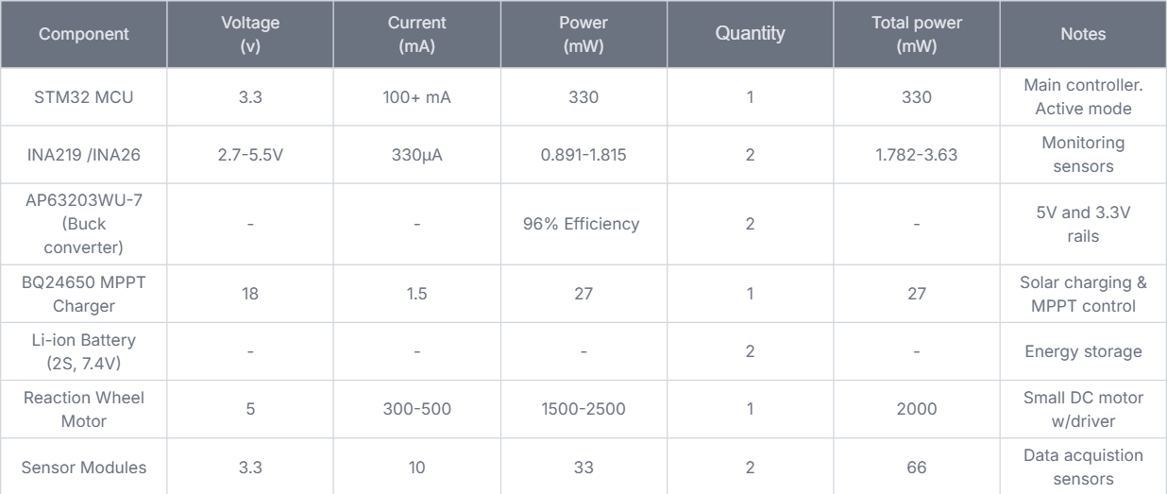
Power Consumption Analysis

Power Sources and Generation
Source | Voltage | Voc | Current (A) | Power (W) | Notes
Solar Panel (20-25W) | 12Nominal / 17Vmp | 21V | 1.2-1.5 | ~20-25 | Main power through mppt requires 21voc according to datasheet.
Battery Pack (2S Li-Ion, 2500 mAh or higher) | 7.4-8.4 | - | 2-4 | ~15-25 | Backup power and energy buffer

Estimated Battery Runtime
For two 3.7 V, 2500 mAh Li-ion batteries in series (≈18.5 Wh total): Idle / Light Load (0.5 W): ~37 hours With Reaction Wheel (2.5 W): ~7 hours Continuous operation during sunlight: Practically indefinite (solar-powered via MPPT).

Expected Outcomes
By the end of the project, we expect to achieve the following outcomes:
- Functional EPS Prototype
  - A fully operational miniature Electrical Power System that can successfully harvest solar energy, charge Li-ion batteries, and regulate power output to multiple subsystems (5 V and 3.3 V rails).
  - Demonstration of real-time energy flow between solar panels, batteries, and loads.
- Efficient Power Management
  - Implementation of a Maximum Power Point Tracking (MPPT) algorithm through the BQ24650 to maximize solar charging efficiency.
  - Stable and efficient voltage regulation using DC-DC converters (AP63203WU-7) under variable load conditions.
- Monitoring and Control System
  - Integration of INA219/INA226 sensors with an STM32 microcontroller to measure voltage, current, and battery state-of-charge.
  - Data logging or display capability to visualize system behaviour and performance during operation.
- Educational Demonstration Model
  - A physical prototype that visually and practically represents how a real CubeSat manages its electrical power.
  - Useful as a training and demonstration tool for future students or research in satellite power systems.
- Design and Documentation Deliverables
  - Complete circuit schematics, PCB layout (KiCad), and a Bill of Materials (BOM).
  - A detailed project report outlining system design, operation, and performance evaluation.
- Future Expansion Possibilities
  - While not finalized, the project may explore the possibility of integrating advanced features such as a radio-frequency antenna, a reaction wheel for orientation control, and a low-power operating mode for improved energy conservation.
  - These features, if approved, would make the prototype more representative of a complete CubeSat platform.

Summary
In summary, this project represents a comprehensive effort to design, simulate, and implement a miniature CubeSat Electrical Power System that models the real-world behavior of satellite energy management. Through careful component selection, circuit design, and microcontroller integration, the team aims to demonstrate how solar energy can be effectively captured, stored, and distributed in small-scale space systems.
The prototype will not only highlight the technical principles behind EPS design but will also serve as an educational and research tool for understanding energy flow, system reliability, and future advancements in CubeSat technology. By potentially incorporating communication and orientation features in later stages.

